Insight
Submitting an External Activity Request and/or
Disclosing a New Financial Interest

Submit an External Activity Request
- Log into Insight: https://emory.researchinsight.org/
- Click on Agreements in the left-hand panel
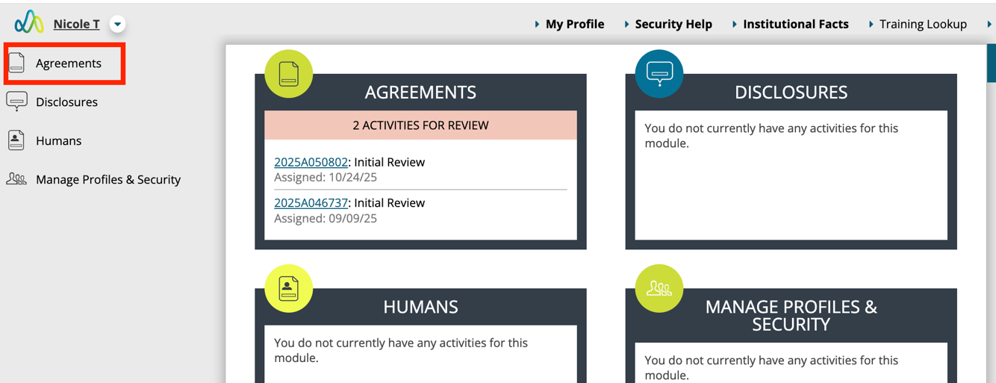
- Click on Create Agreement in the left-hand panel.
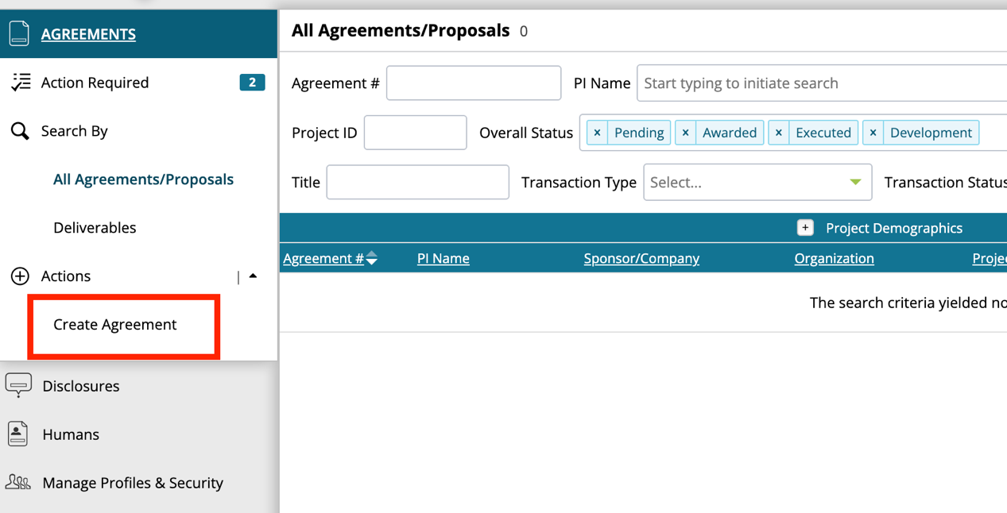

- In the pink External Activities box, click “Yes, I am submitting a record related to external activities”
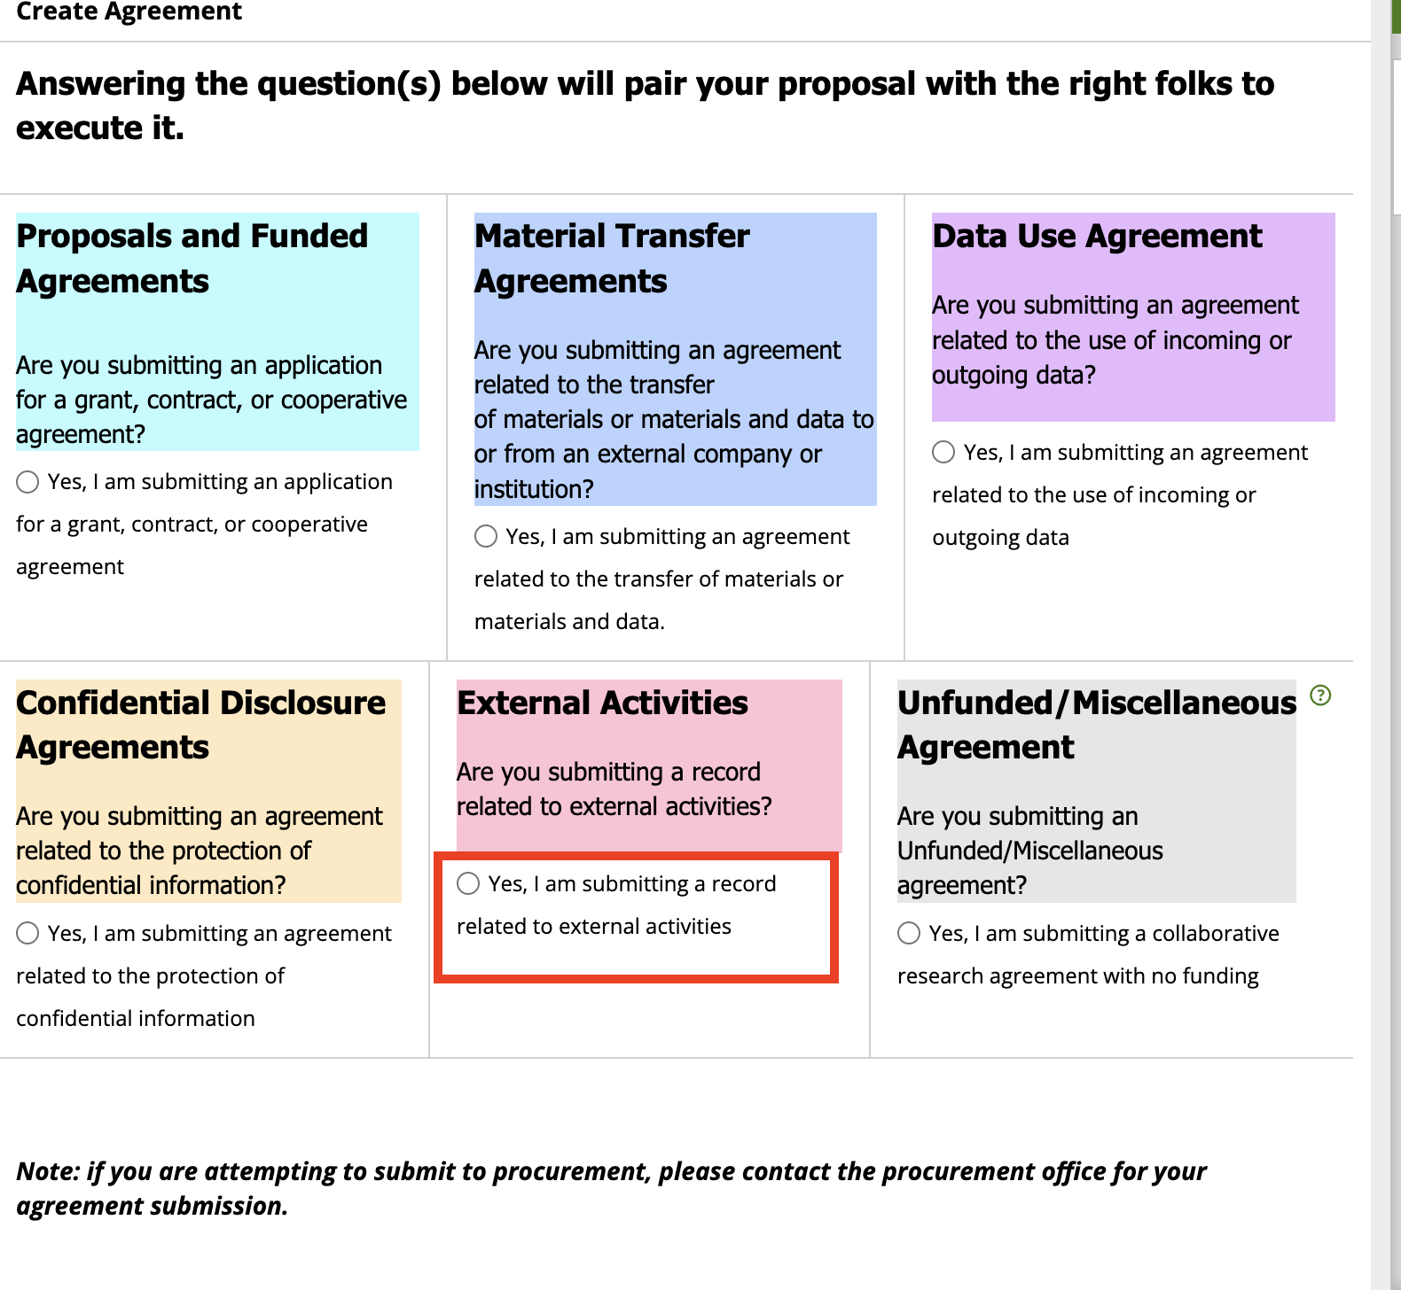
- Enter your name under the question “Who is the Emory Principal Investigator (PI) for this agreement?” and select yourself. Please enter in the following format: Last name, First Name
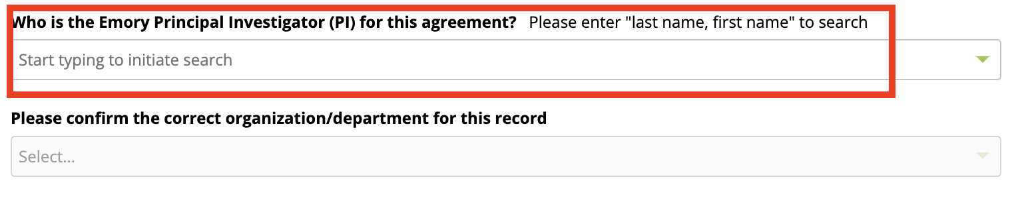
- In the lower righthand corner, click Create.


- The form will open. Enter a title for your request and click Next in the lower righthand corner.
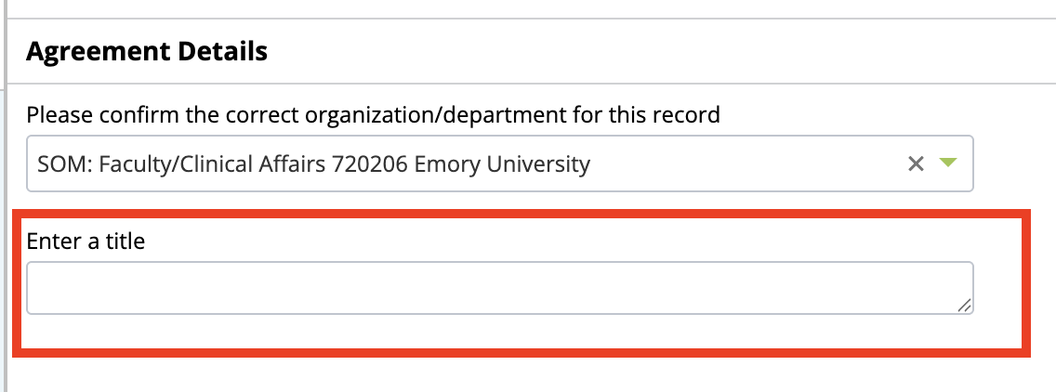

- Type the name of the External Entity in the box.
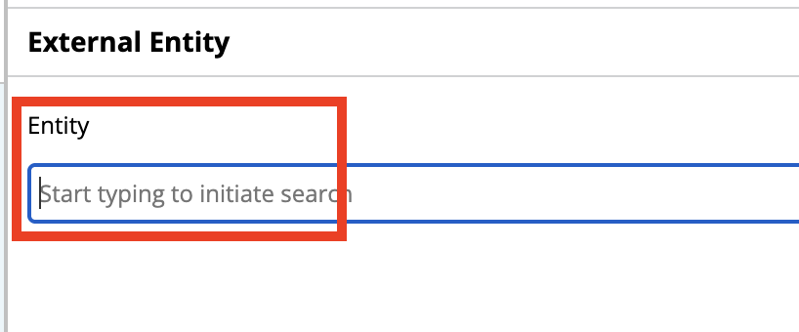
If the entity is not already in Insight’s database, the box will display “No results found” and you will need to create a new entity by clicking on Create a New External Entity. A popup will appear. Answer the questions and click Save.
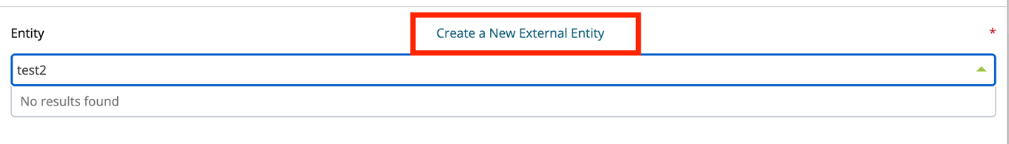
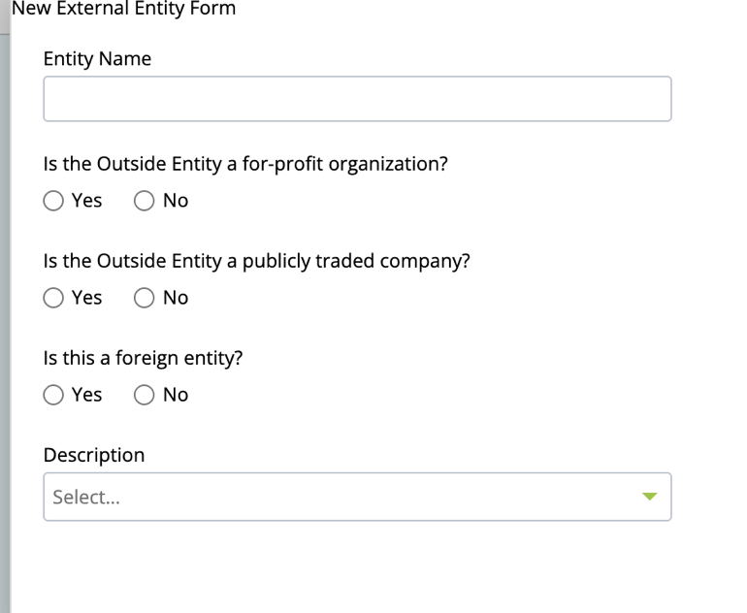


Click Next to advance to the next page.
- Answer the questions on the External Activities page. If you are a SOM faculty physician, select Emory University and Faculty to ensure that your request routes to your Department Chair and the Dean’s Office.
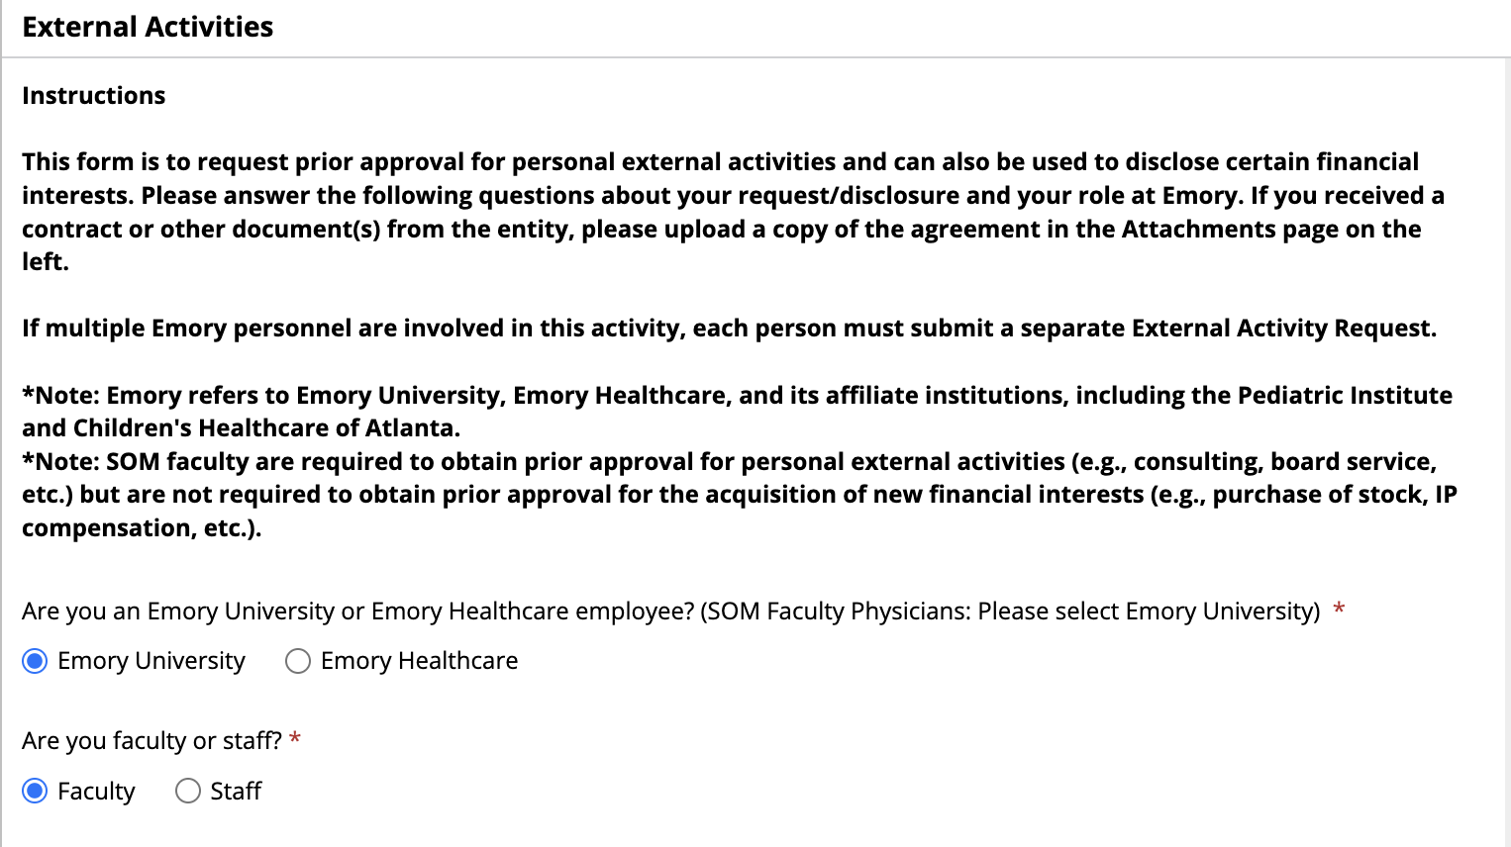
- Click Next to advance to the Staff page.
- On the Staff page, click Next. (You should not add any additional Emory or External Staff on this page as each person will need to complete their own request).

- On the Attachments page, upload any relevant attachments.
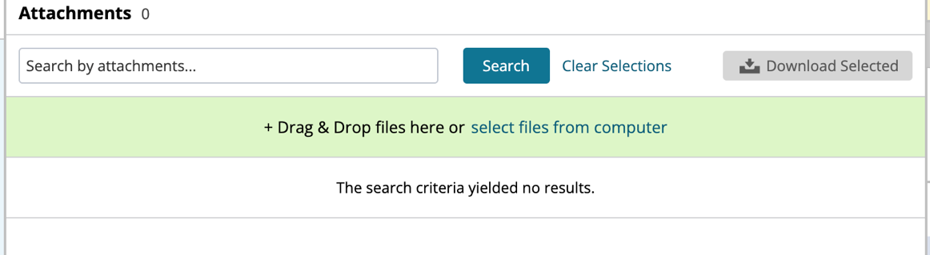
- Check the lefthand column to make sure all sections have a green checkmark. You will not be able to submit the request if there are any red exclamation points.
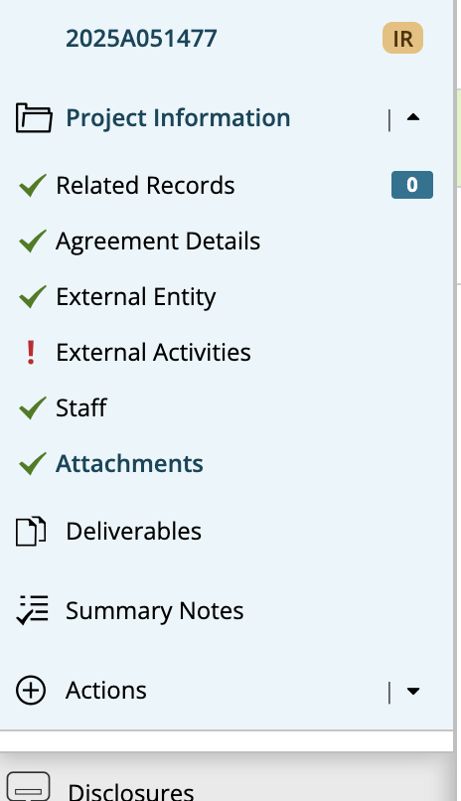
- Once all responses are complete, navigate to the right of the screen, and confirm that the Submission Checklist shows the message “All validations in this area have been completed.” This indicates the form is complete and ready to submit.
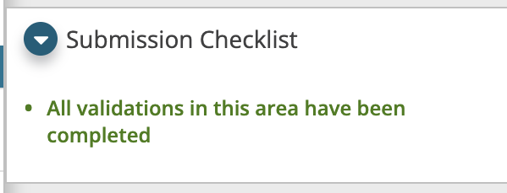
- When you are ready to submit the form, click the checkbox by the message “I have carefully reviewed this record and confirm my sign off.” Then click Submit. If you want to save your form without submitting, click Save. If you want to withdraw your request, click Withdraw.
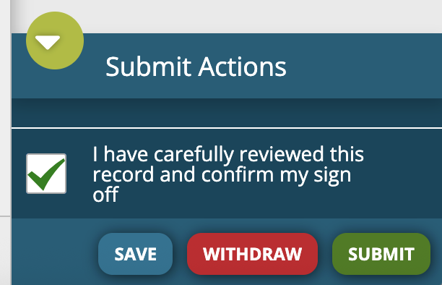

Resources
- Visit SharePoint here for more information
- For technical issues, contact IT

