Insight
Completing Your Annual Disclosure in the Disclosures Module

How-To Guide
Insight is Emory University’s platform for managing research protocols and related administrative workflows. The annual disclosure process is required for Emory faculty and staff and helps ensure transparency around outside interests, financial relationships and potential conflicts of interest. This guide provides step-by-step instructions for completing the Annual Disclosure with instructions for answering required questions, disclosing external activities and submitting the completed form.

Complete Your Annual Disclosure
- Log into Insight: https://emory.researchinsight.org/
- Click on Disclosures in the lefthand panel
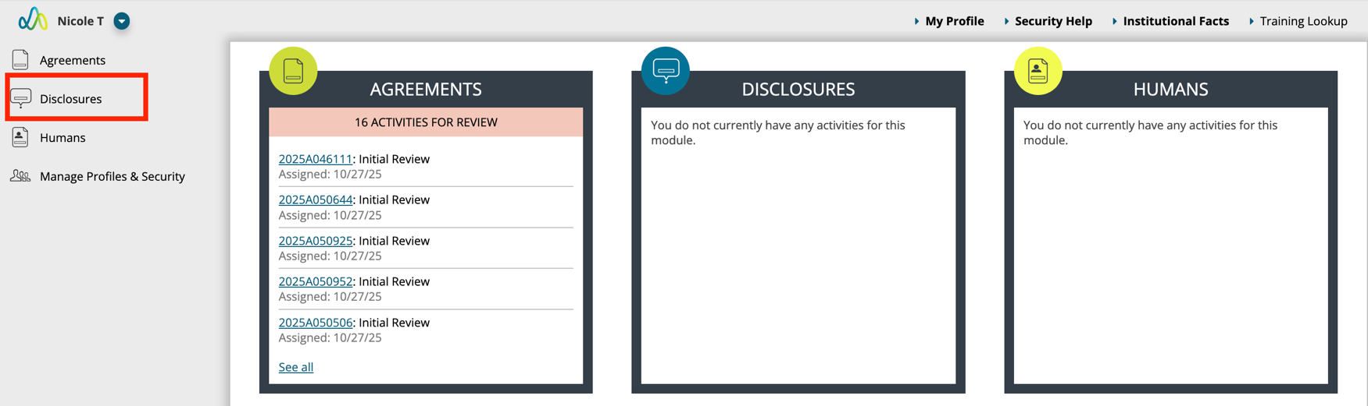

- Click on My Annual in the lefthand panel. Read the instructions and click on Start Annual Cycle.
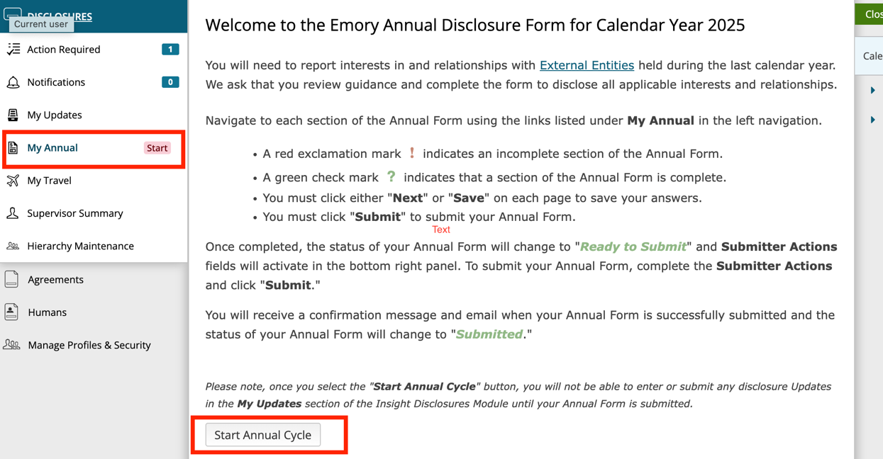

- The Annual Certification Form will open. Answer the questions by clicking the button next to each appropriate answer. As you respond, the fields update dynamically, and “Yes” answers prompt you for more details. Upload any supporting documentation to the attachments section as appropriate.
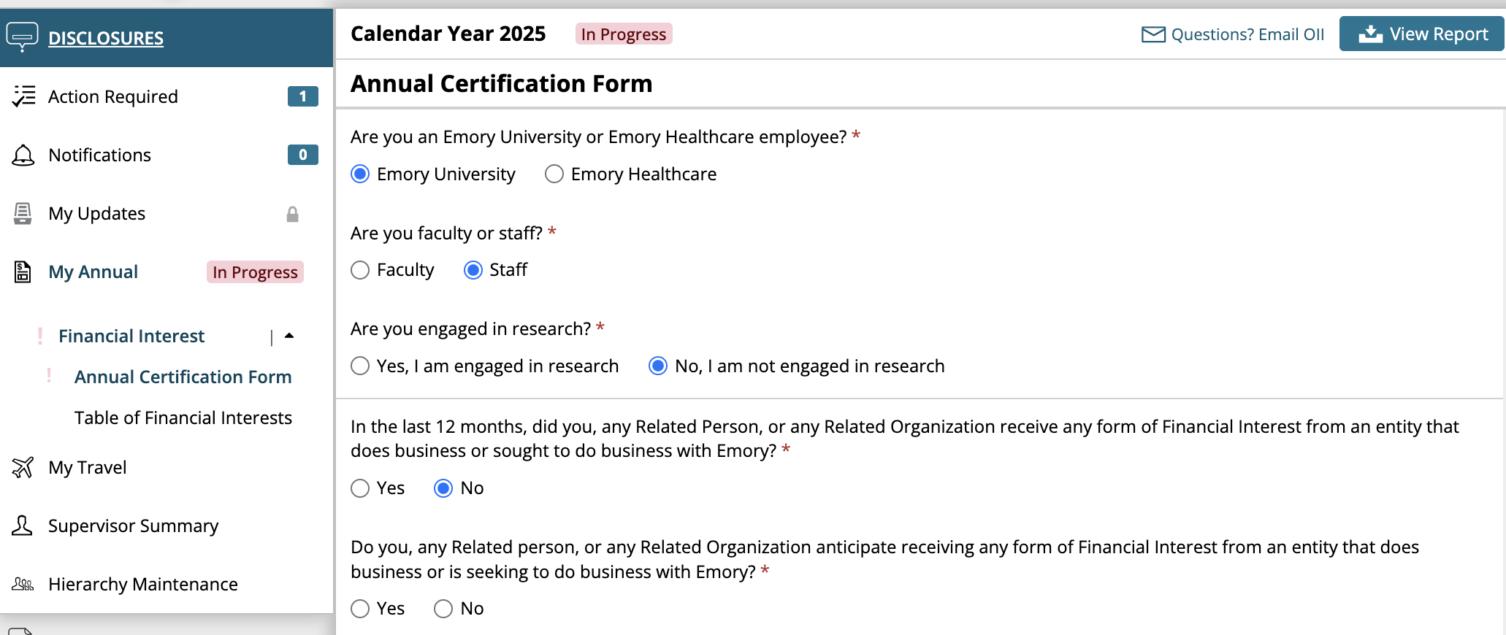
- When you finish answering all questions on the form, click Next at the bottom right of the page. This will take you to the Table of Financial Interests page.


- The Table of Financial Interests will open. To add a new financial interest, click Add Entity.
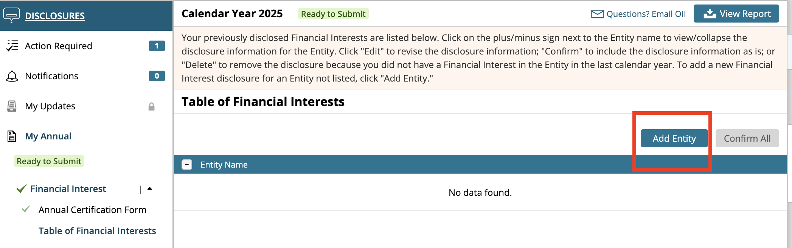

The Financial Interest Disclosure form will open. In the search field at the top of the page, type the name of the entity linked to your external activity, then select the company or organization from the list of results. Answers to the entity-related questions will automatically populate based on existing system data for that entity. Review the auto-filled information about the entity and confirm its accuracy.
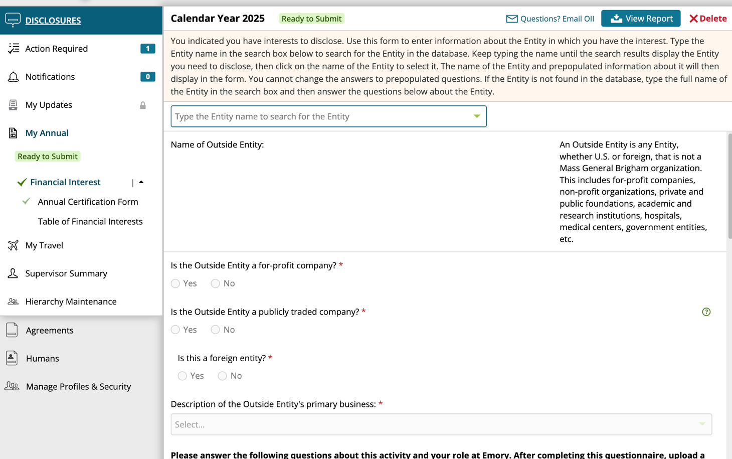

To add another financial interest, click Add Entity.

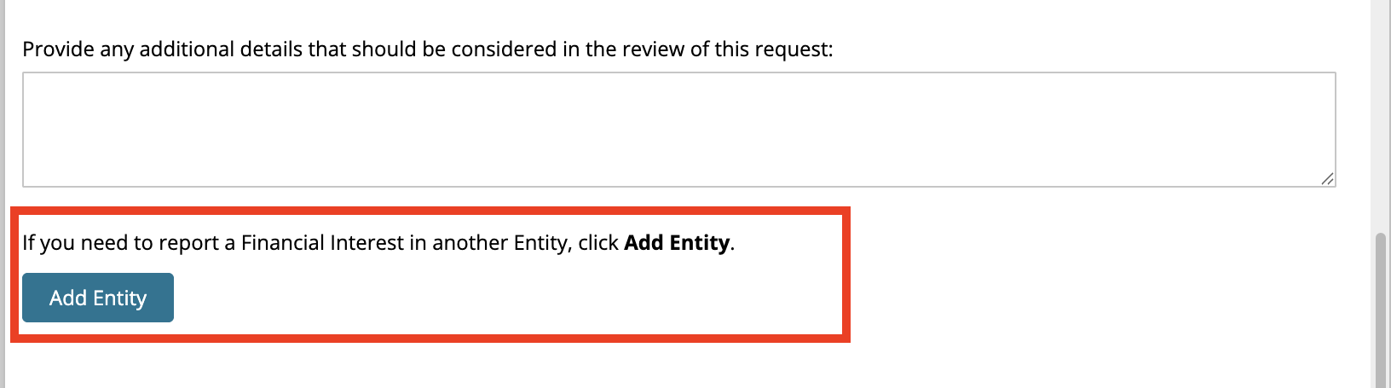

If you have existing financial interests, they will populate in the Table of Financial Interests. Review all compensation reported. Click Confirm if the information is accurate. Click Edit to revise the information if it is not accurate. Click Add Entity to add any new financial interests following the steps above. Click Confirm All to confirm all financial interests at the same time.

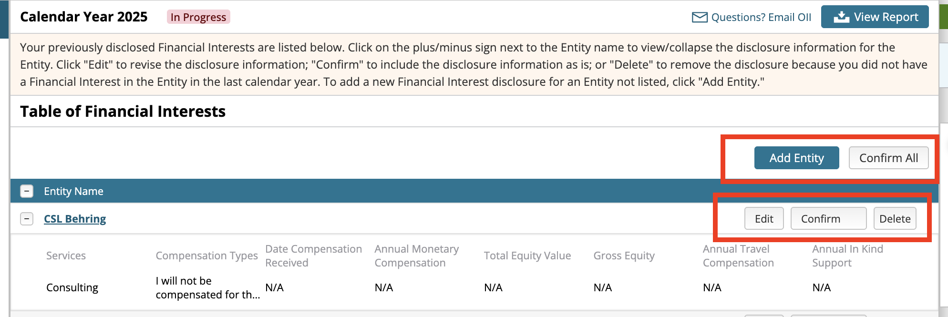

- Once all financial interests are accurately reported in the Table of Financial Interests, click Next.
- Once all responses are complete, navigate to the right of the screen, and confirm that the Submission Checklist shows the message “All validations in this area have been completed.” This indicates the form is complete and ready to submit.
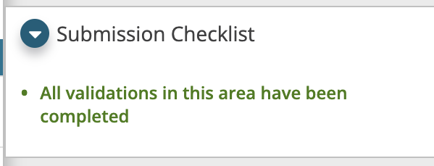
- When you are ready to submit the form, click the checkbox by the message “I have answered fully and to the best of my ability” at the bottom right of the screen. Then click Submit.
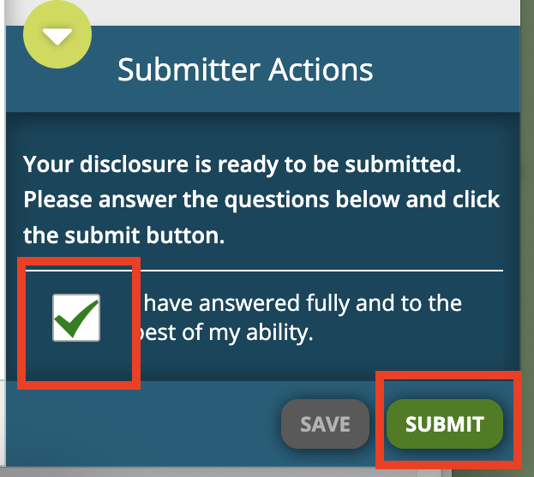

Resources
- Visit SharePoint here for more information
- For technical issues, contact IT by emailing insighthelp@emory.edu

